PROJECT REPORT

**ON**

PREDICTING LIFE EXPECTANCY

Submitted By:

Preetika Thakur

B.Tech(Computer Science)

**TABLE OF CONTENTS**

* + - * INTRODUCTION

Overview

Purpose

LITERATURE SURVEY

* + - * + Existing Problem
        + Proposed Solution
      * THEORETICAL ANALYSIS
        + Block Diagram
        + Hardware/Software Designing
      * FLOWCHART
      * RESULT
      * ADVANTAGES & DISADVANTAGES
      * APPLICATIONS
      * CONCLUSION
      * FUTURE SCOPE
      * BIBILOGRAPHY
      * APPENDIX

Source Code

# INTRODUCTION

* 1. Overview

The project tries to create a model based on data provided by the World Health Organization (WHO) to evaluate the life expectancy for different countries in years. The data offers a timeframe from 2000 to 2015. The data originates from here: <https://www.kaggle.com/kumarajarshi/life-expectancy-who/data>.

* **Technical Requirements:**

Knowledge of basics of Python, ML and statistics

* **Software Requirements**:

IBM Watson Services, IBM Cloud, Jupyter Notebook, NODE RED.The model as formulated using the Machine Learning Service in IBM cloud while the front-end UI was created using NODE-RED. The ML model was connected to the UI using the service endpoint.

* **Hardware Requirements:**

IBM Cloud Storage and services, Desktop were used to complete this project.

1.2 Purpose

The purpose of this project is to predict the average life expectancy of people living in a country when various factors such as year, GDP, education, alcohol intake of people in the country, expenditure on healthcare system and some specific disease related deaths that happened in the country are given.

# LITERATURE SURVEY

* 1. Existing Problem

Life expectancy is one of the most important factors in end-of-life decision making. Good prognostication for example helps to determine the course of treatment and helps to anticipate the procurement of health care services and facilities, or more broadly: facilitates Advance Care Planning. Advance Care Planning improves the quality of the final phase of life by stimulating doctors to explore the preferences for end-of-life care with their patients, and people close to the patients. Physicians, however, tend to overestimate life expectancy, and miss the window of opportunity to initiate Advance Care Planning.Thus here we are using machine learning technique for predicting life expectancy.

* 1. Proposed Solution

The task of predicting life expectancy can be approached as as a supervised machine learning task. We train and test a lasso regression model on the records present in dataset and then deploy the trained model with help of ibm cloud services.

3.Theoretical Analysis

3.1 Block Diagram

3.2 Hardware/Software Designing

First we have to collect the data from the dataset then import the libraries using pandas then applying data cleaning techniques ( refine the data). This model is divided into two part train and test . Then train the data using Lasso regression and build a model for testing . After making the model, this model is deployed using Watson studio.After this we will create a node red ui and finally integrate the model and node-red ui.

1. Node red Flow

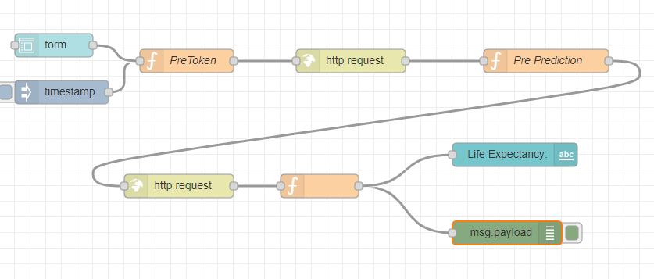

1. UI

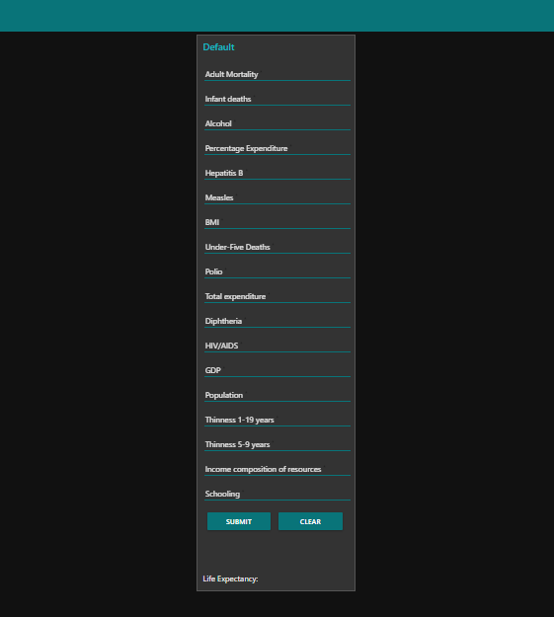

# FLOWCHART

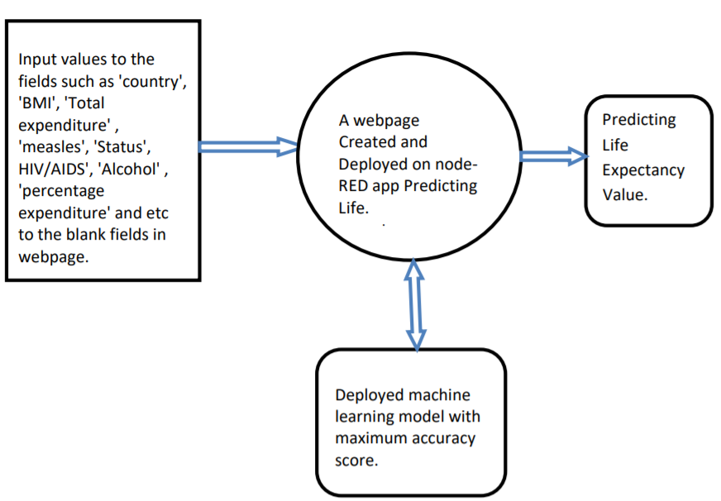

# RESULT

We obtain a UI that is used to prompt the user to take input in the form of the following variables: 

The above UI allows the user to enter the required fields in order to predict the approximate age that is to be expected for the entered set of input values. The prediction is evaluted to be accurate in the range of 80%-90%.

# ADVANTAGES AND DISADVANTAGES

ADVANTAGES:

1)Helpful for a country for analysis: It will be easier for a country to determine the predicting factor which is contributing to lower value of life expectancy. This will help in suggesting a country which area should be given importance in order to efficiently improve the life expectancy of its population.

2) Reduced Costs: This is a simple webpage and can be accessed by any citizen of a country to calculate life expectancy of their country and does not required any kind of payment neither for designing nor for using.

3) User Friendly Interface: This interface requires no background knowledge of how to use it. It’s a simple interface and only ask for required values and predict the output.

DISADVANTAGES:

1)Prediction may not be accurate: As it depends completely on user, so if user provides some wrong values then it will predict wrong value.

2) Average Prediction: The model predicts average or approximate value with 94.07% accuracy but not accurate value.

# APPLICATIONS

* It can be used to monitor health inequalities of a country.
* It can be used to develop statistics for country development process.
* It can be used to analyse the factors for high life expectancy.
* It will help government prepare life insurance policies for people

# CONCLUSION

The Linear Regression model that is created can be used to accurately predict the expected approximate age for a given set of values that act as the independent variables that help train the model. The values predicted by the model are based on the values that were previously used to train the model and hence the accuracy of the prediction is solely dependant on the extent of training done to the model and the number of variables that are given as an input.

# FUTURE SCOPE

The ML model used can be changed to accommodate a larger set of values a produce a non-linear prediciton output. This can also be done to improve accuracy as well as reduce overfitting and bias. There can be further grouping and refining done to the dataset as well.

# . BIBLIOGRAPHY

* <https://cloud.ibm.com/docs/overview?topic=overview-whatis-platform>
* <https://developer.ibm.com/tutorials/how-to-create-a-node-red-starter-application/>
* <https://nodered.org/>
* <https://github.com/watson-developer-cloud/node-red-labs>
* <https://www.kaggle.com/kumarajarshi/life-expectancy-who>

# 11. APPENDIX

# **Source_Code:** <https://github.com/SmartPracticeschool/llSPS-INT-2071-Predicting-Life-Expectancy-using-Machine-Learning>